H& M Customer Behavior Analysis

1. Project Overview
This project analyzes customer shopping behavior using transactional data from 3,900 purchases across various product categories. The goal is to uncover insights into spending patterns, customer segments, product preferences, and subscription behavior to guide strategic business decisions.
2. Dataset Summary
- Rows: 1000
- Columns: 18
- Key Features:
  - Customer demographics (Age, Gender, Location, Subscription Status)
  - Purchase details (Item Purchased, Category, Purchase Amount, Season, Size, Color)
  - Shopping behavior (Discount Applied, Promo Code Used, Previous Purchases, Frequency of Purchases, Review Rating, Shipping Type)
- Missing Data: 483 values in Discount applied column
3. Exploratory Data Analysis using Python
We began with data preparation and cleaning in Python:
- Data Loading: Imported the dataset using pandas.
- Initial Exploration: Used df.info() to check structure and .describe() for summary statistics.
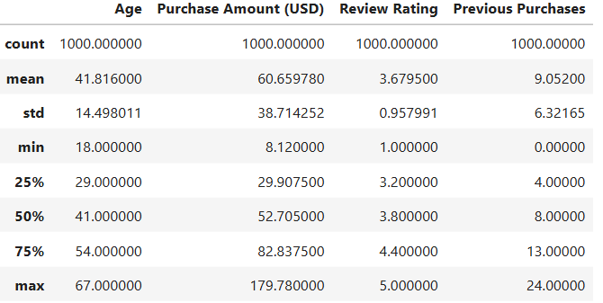
- Missing Data Handling: Checked for null values and imputed missing values in the Discount Applied and Promo Code used
- column using the median rating of each product category.
- Column Standardization: Renamed columns to snake case for better readability and documentation.
- Feature Engineering:
  - Created age_group column by binning customer ages.
  - Created purchase_frequency_days column from purchase data.
- Data Consistency Check: Verified if discount_applied and promo_code_used were redundant; dropped promo_code_used.
- Database Integration: Connected Python script to PostgreSQL and loaded the cleaned DataFrame into the database for SQL analysis.

4. Data Analysis using SQL
We performed structured analysis in PostgreSQL to answer key business questions:
- Revenue by Gender – Compared total revenue generated by male vs. female customers.
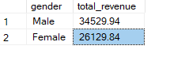
2.Subscribers vs. Non-Subscribers – Analyzed revenue differences between the two groups.
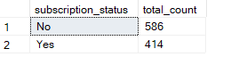
3.Top 5 Most Purchased Items – Identified the most popular products.
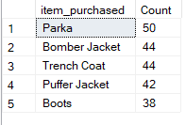
4.Average Sales Amount by Age Group – Determined spending behavior across age categories.
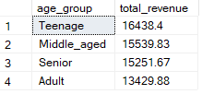
5. Promo Code Performance – Found the promo code generating the highest revenue.
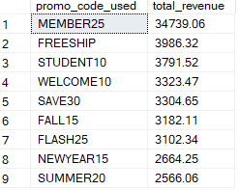
6.Average Purchase Amount and Total Customers by Location – Evaluated regional spending patterns.
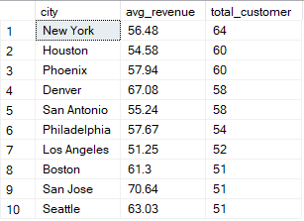
7.Shipping Type Comparison – Compared average purchase amounts across different shipping methods.
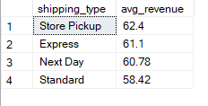
8.Top-Rated Item – Identified items with the highest average review ratings.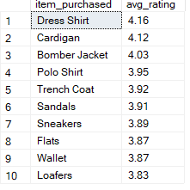
9.Purchase Frequency Impact – Examined how purchase frequency affects average spending.
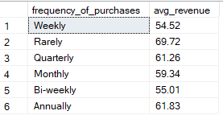
5.Dahboard with Power BI
A comprehensive Power BI dashboard was developed to visualize:
- Customer segmentation by gender, age, and location
- Revenue contribution by subscribers and non-subscribers
- Top-performing products and promo codes
- Correlations between review ratings, purchase frequency, and spending behavior

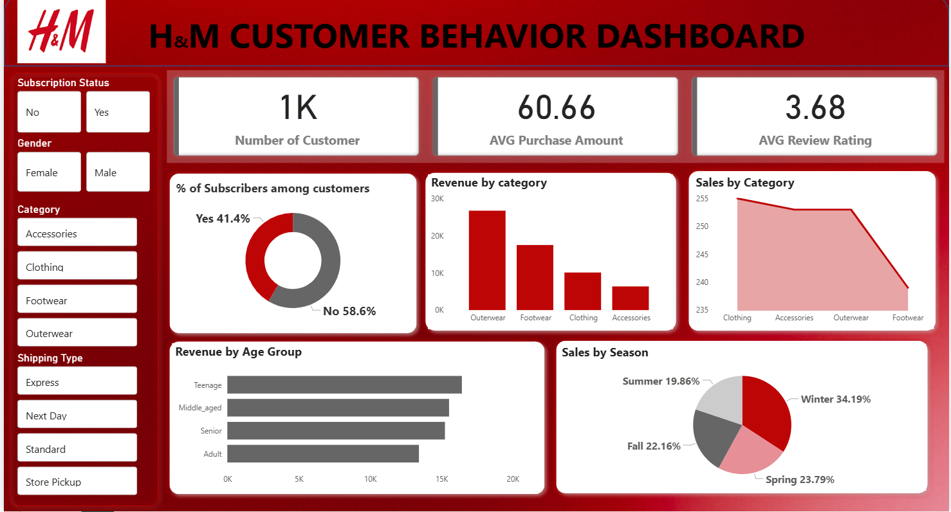
6. Business Recommendations
- Boost Subscriptions – Promote exclusive benefits for subscribers.
- Customer Loyalty Programs – Reward repeat buyers to move them into the “Loyal” segment.
- Review Discount Policy – Balance sales boosts with margin control.
- Product Positioning – Highlight top-rated and best-selling products in campaigns.
- Targeted Marketing – Focus efforts on high-revenue age groups and express shipping users.

